25.online voting syatem

Use case diagram

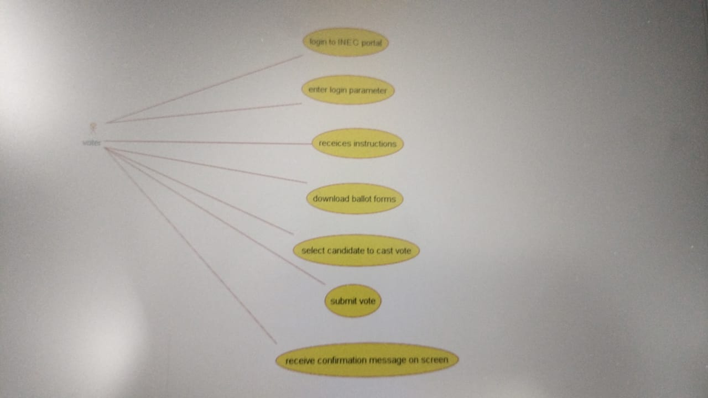

Class diagram

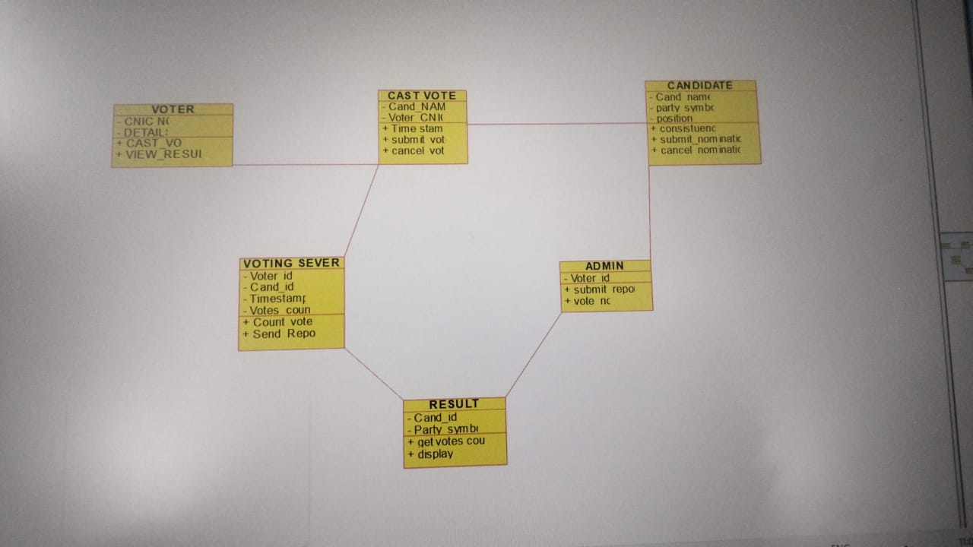

Source code

#ifndef ADMIN_H

#define ADMIN_H

#include <string>

#include vector

/**

* class ADMIN

*

*/

class ADMIN

{

public:

// Constructors/Destructors

//

/**

* Empty Constructor

*/

ADMIN ();

/**

* Empty Destructor

*/

virtual ~ADMIN ();

// Static Public attributes

//

// Public attributes

//

// Public attribute accessor methods

//

// Public attribute accessor methods

//

/**

*/

void submit_report ()

{

}

/**

*/

void vote_no ()

{

}

protected:

// Static Protected attributes

//

// Protected attributes

//

public:

// Protected attribute accessor methods

//

protected:

public:

// Protected attribute accessor methods

//

protected:

private:

// Static Private attributes

//

// Private attributes

//

void Voter_id;

public:

// Private attribute accessor methods

//

private:

public:

// Private attribute accessor methods

//

/**

* Set the value of Voter_id

* @param new_var the new value of Voter_id

*/

void setVoter_id (void new_var) {

Voter_id = new_var;

}

/**

* Get the value of Voter_id

* @return the value of Voter_id

*/

void getVoter_id () {

return Voter_id;

}

private:

void initAttributes () ;

};

#endif // ADMIN_H